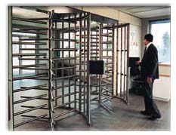
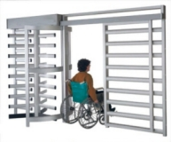
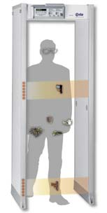
July 13, 2006

Frank T. Rivera
Col., US Army, Retired
Century Security
7915 SW 104 St
St G101
Miami, FL 33158
Tel: 305 273 5241 Cal: 305 298 8393
Email: frivera1@bellsouth.net

RE: Turnstiles, Face Recognition, Fingerprint Scanner, Access Control (EntraPASS)
For Quito, Ecuador
Dear Mr. Rivera,

The following is a list of equipment and services to be provided by www.TURNSTILES.us, inc. in accordance to our telephone conversation on Wednesday, July 12th, 2006 and your email sent at 1:19pm.

(6) Prison Grade U-Shaped Arm Turnstiles, Galvanized Steel,
2-Way Electric, Full Height,
Model MPT-30ECG, $ 4,650.00 each $ 27,900.00

(12) Vandal Resistant Cameras, Rugged Series High Res,
Day/Night, Color & B&W, Weatherproof,
Model EL-8720BDN-IR/2.9, $ 436.00 each $ 5,232.00

(12) 12vDC 1A Power Supplies with Terminal
( for Cameras ), Model RTD-12/10RT, $ 26.00 each $ 312.00

(1) 16 Channel DVR with Audio, 240 FPS,
1200 Gig Hard Drive, Windows 2000 / XP Professional,
Model ETM-240-16/1200 $ 12,524.00

(1) UPS Battery Back-Up for DVR, 350VA, 6 Outlet, 3 w/Surge,
Includes RS232 to USB Converter,
Model EL-DVR-325VA Kit $ 128.00

(1) Remote Administration Software License for
DVR Remote Management, Model RADMIN $ 74.00

Page Two
Century Security
Quito, Ecuador

(1) Facial Recognition Access Control CPU, Windows 2000 / XP,
Model FaceVACS $ 11,916.00

(1) Access Control CPU, Windows 2000 / XP,
Model EntraPASS Corporate Edition Server
Includes 1-Server License, 1-Gateway License,
5-Workstation License $ 8,119.00

(1) Access Control Gateway CPU, Windows 2000 / XP $ 1,715.00

(1) Workstation CPU, Windows 2000 / XP $ 1,715.00

(5) LCD Monitors, Philips BRILLIANCE 200P6EB/27
( 1 – DVR / 1 – Facial Recognition / 1 – EntraPASS Server
1 -EntraPASS Workstation / 1 – EntraPASS Gateway )
20-inch Black UXGA Multimedia LCD Monitor
Model 200P6EB/27, $ 517.90 each $ 2,589.50

(12) Fingerprint Scanners with integrated keypad,
2000 User Memory Upgrade,
Model FingerKey DX2000/FPM-2000, $ 1,199.00 each $ 14,388.00
Equipment Total: $ 86,612.50
Freight to Quito: $ 3,110.50
Grand Total: $ 89,723.00

Value Added Service: we shall provide the following at no additional cost:

(*) AutoCAD Device Location Drawing detailing Equipment Location, Electrical Requirements, and Cable Routing.

(*) AutoCAD Installation Schematic with point-to-point wiring harness
(*) AutoCAD Drawings will be emailed, and 3 Copies of 24 x 36” D-Size Plots will
be sent UPS.

(*) Unlimited Telephone Support (including evenings and weekends) until you are up and running (you will have home and cellphone numbers of 2 Engineers).
(*) All Low Voltage Cabling is included. All mounting hardware is included.

Page Three
Century Security
Quito, Ecuador

Past Experience:

www.TURNSTILES.us currently have similar systems in Six (6) U.S. Federal Penitentiaries, Alcoa Aluminum – Lafayette, Indiana, Compact Industries – St. Charles, IL., Interdent – Philippines’, Canadian Embassy – China, Ceasers Casino – Lake Tahoe, Four (4) R.R. Donnelley Publishing Facilities, Three (3) Archer Daniels Midland (ADM Corn Processing) Facilities, Honeywell Aerospace – Calexico – for additional clientele please visit http://turnstiles.us/references.htm

Equipment Documentation / Literature:

We will post a private link containing all literature (as it will be too large to email ).

Your literature will be located at www.turnstiles.us/centurysecurity.htm

We appreciate the opportunity to service you, as we look forward to working with you on this interesting project.

Sincerely yours,
www.turnstiles.us, inc.
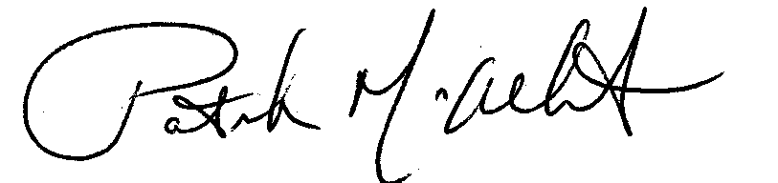

Patrick McAllister
President, Corporate Engineering
PM/deg

